“Evaluating benefits to ecosystem services in coho fisheries areas derived from genome technologies designed to boost coho productivity”

Travis C. Tai, U. Rashid Sumaila

Outline

* Fishing area closures to Coho fisheries due to poor health of coho stocks
  + Benefits
    - Ecosystems, reduced fishing effort, less bycatch and habitat destruction, allows other stocks to improve with intermittent closures, could improve overall biodiversity of ecosystem
  + Costs
    - Losses of other fisheries for closed areas, loss of livelihoods and incomes, economic input, loss of food security, decreased supply and potential effects on demand and price
* Fishing area not closed during coho migration with improved stocks and productivity due to genome technologies
  + Benefits
  + Costs
* benefit ecosystem as a whole

Abstract

**Notes**

IFMP DFO 2019-2020 – Integrated Fisheries Management Plan

<https://waves-vagues.dfo-mpo.gc.ca/Library/40799104.pdf>

SECTION 13.3 – SOUTHERN COHO FISHING MANAGEMENT PLAN

* Southern coho broken up into conservation units, falling into to broader categories: WCVI Coho, and South Inside Coho

South Inside Coho

* Five populations within South Inside Coho:
  + Four management units: Lower fraser, interior fraser, SoG Mainland, SoG Vancouver Island
  + Johnstone Strait group: Four conservation units – none are actively managed
* Stock assessments: Conservation strategy for Coho (CSAS) from 2006, 2 main objectives for South Inside Coho enhancement:
  + 3-year average escapements in at least 50% of sub-populations within each of the 5 populations to exceed 1,000 wild-origin spawning salmon. Total target escapement for the Interior Fraser Coho to be 20-25k wild-origin Coho.
  + Maintain productivity of Interior Fraser Coho so recovery is sustained. Ensure threats to recovery are addressed, through addressing the causes for decline identified by COSEWIC.
* Pre-season status:
  + Johnstone Strait: low-near target
  + SoG: low target for wild, near target for hatchery
  + Lower Fraser: stock of concern
  + Interior fraser: stock of concern
* Fraser river fisheries “window closures”
  + To protect migrating coho from non-slective fishing gear (e.g. gillnets, rod and reel fishing with bait).
  + Applied to commercial, recreational, and FN
  + Selective fishing gear has been allowed (e.g. beach seines, shallow seines, rod and reel fishing no bait, dip nets).
  + Window closures selected to protect 90% of coho migration
* Non-retention or time and area closures for following (Coho?) fisheries:
  + West Coast Vancouver Island (WCVI) troll (commercial and First Nations) and recreational fisheries in offshore areas from June until early September; •
  + Commercial net and recreational fisheries in the Straits of Juan de Fuca from June until early October;
  + Commercial, recreational and First Nations fisheries in Johnstone and Queen Charlotte Straits from early June until late August;
  + Commercial, recreational and First Nations fisheries in the Strait of Georgia from June until early October;
  + Commercial, recreational and First Nations fisheries both off the mouth of, and in, the Fraser River from early June until mid-October; and,
  + Commercial, recreational and First Nations fisheries in the Fraser River upstream of Sawmill Creek from mid- to late September until late October.
* For 2019, based on poor marine conditions and on-going low productivity regime, the Department is planning to manage Canadian fisheries in a highly precautionary manner with fisheries management measures similar to those in place prior to 2014.
* In Regions 3, 5A, 7 and 8, there are no recreational fisheries that target Coho. Fisheries for other species may be limited after September 16 if they potentially have impacts on co-migrating Coho.
* Commercial fisheries are managed to avoid impacts to Southern Inside Coho. Generally all Coho caught incidentally during fisheries targeting other species must be released in a manner that causes the least harm. Estimates of release mortality are calculated post-season. Fisheries targeting other salmon species may be constrained if potential impacts to IFR Coho cannot be reduced to an acceptable level.

2020/05/04

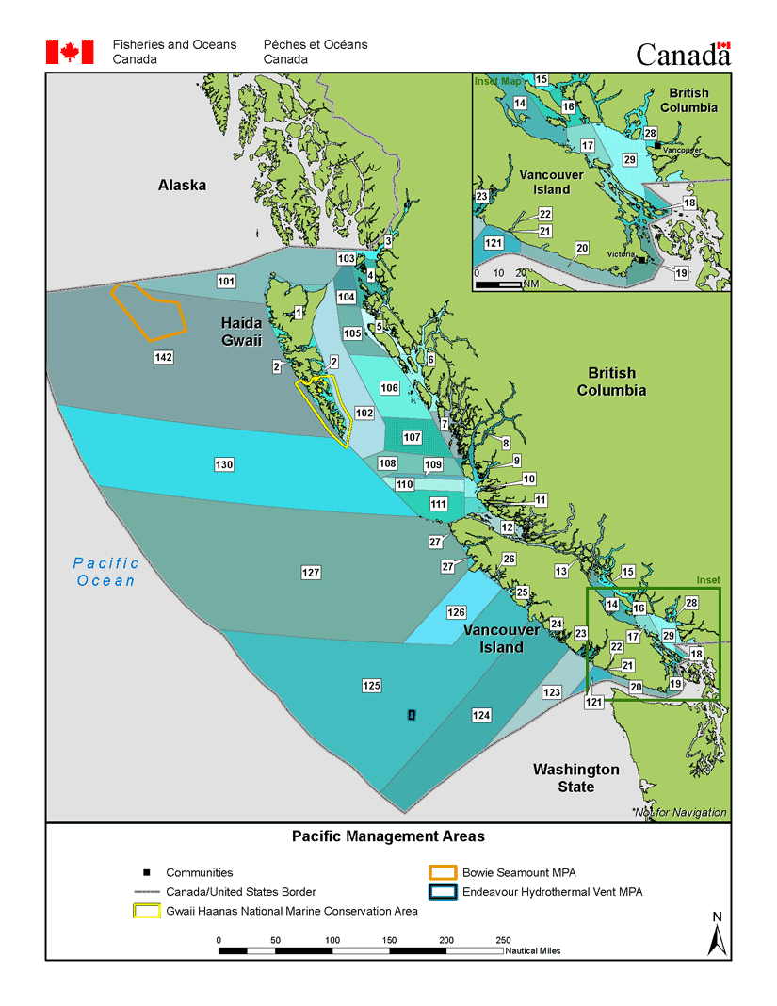

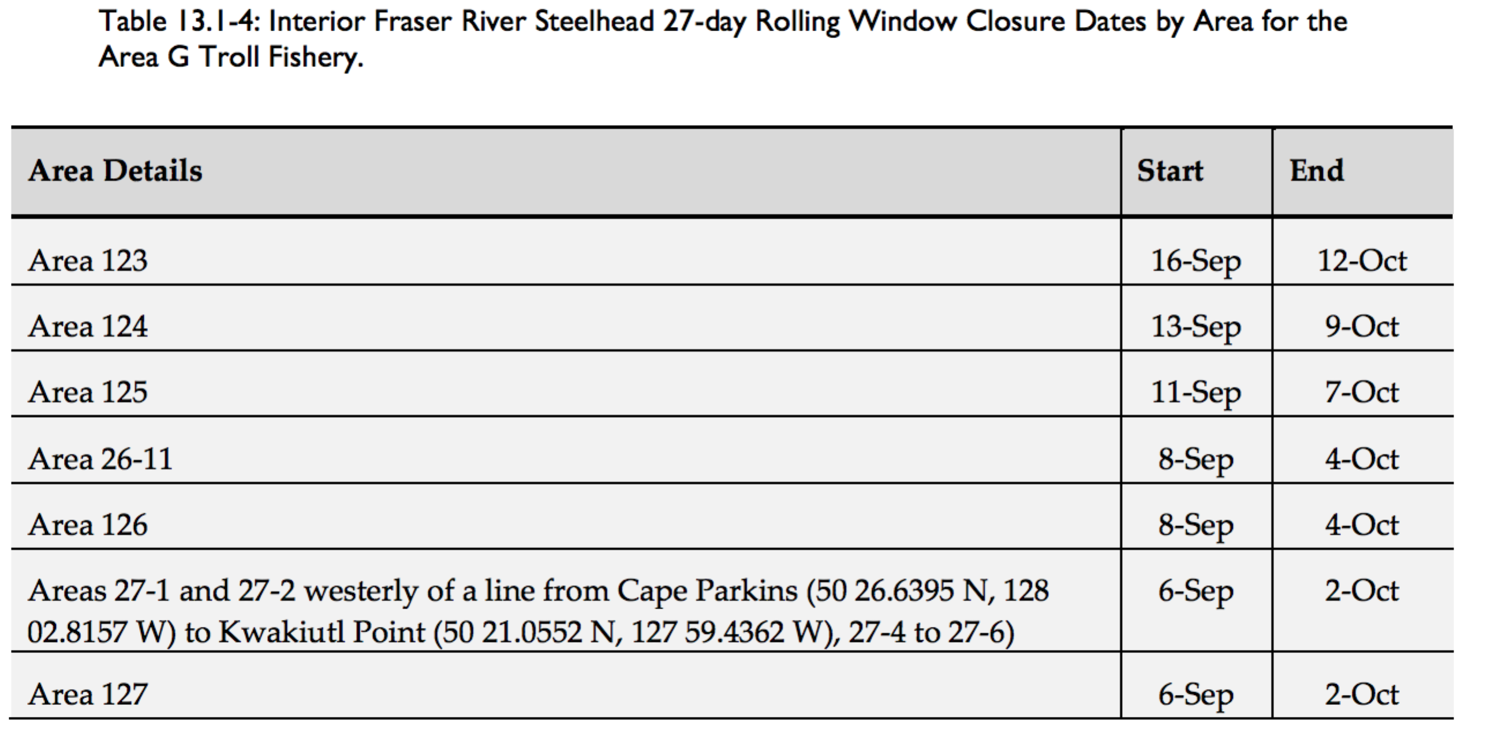

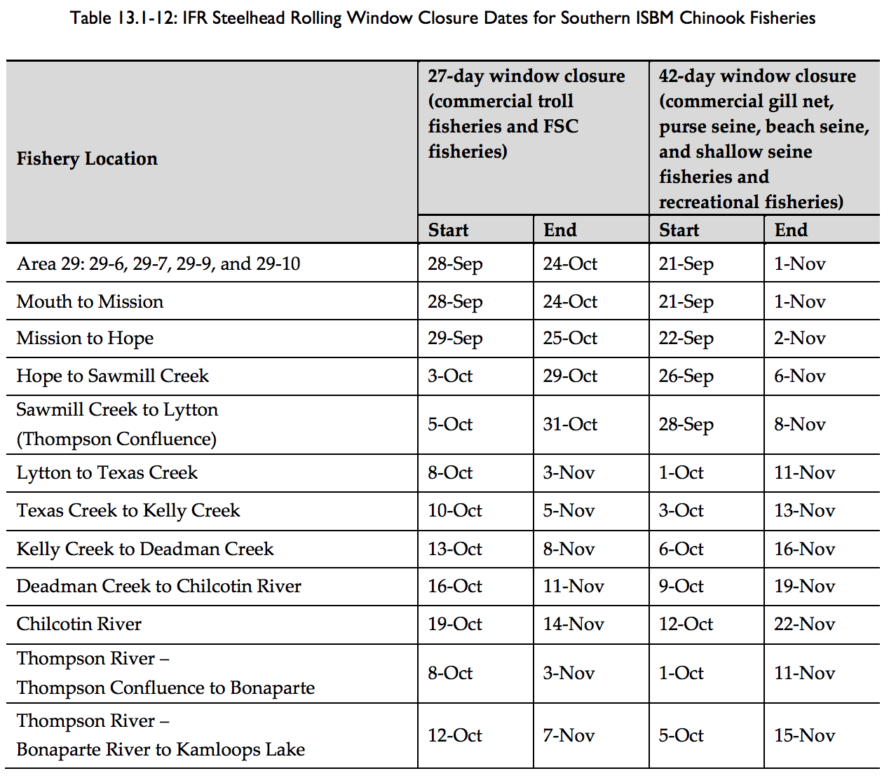

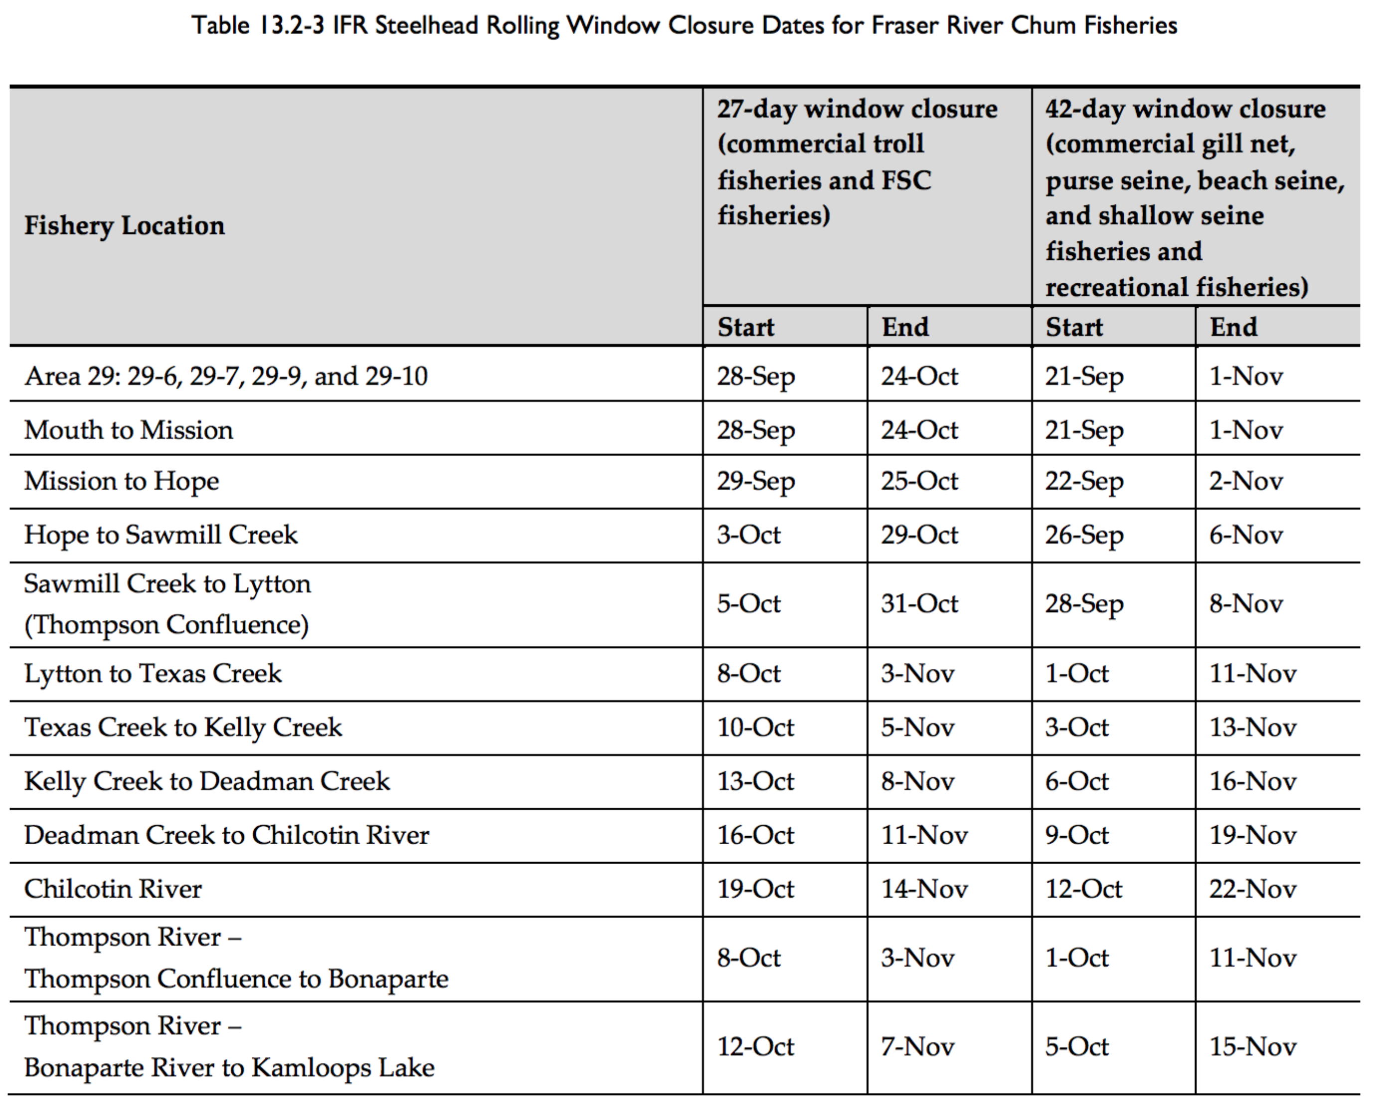

Coho

